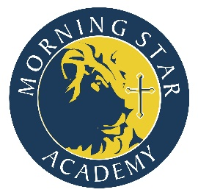
K-6th Boys Dress Code
Boys
Monday, Tuesday, Thursday
Shirts | Pants | Shoes | Socks | Accessories
White, navy, or light blue polo with MSA logo  White button up with logo  3rd and up must tuck in shirt at all times | Khaki or navy shorts or slacks  No sweatpants | Solid white, black, brown, grey, or navy  tennis shoes or dress shoes only  No sandals, flip flops, boots, clogs, character, or light up shoes | Solid white, navy or black anklet or crew socks | 3rd and up brown or black belt required

Boys
Wednesday—Chapel Attire
Shirts | Pants | Shoes | Socks | Accessories
White polo with MSA logo  Navy sweater with logo (optional)  Shirt must be tucked in K-6 | Navy shorts or Slacks | Solid white, black, brown, grey, or navy dress shoes or tennis shoes | Solid navy or black crew socks | Brown belt

Boys
Friday
Shirts | Pants | Shoes | Socks | Accessories
MSA Spirit Wear | Jeans | Tennis Shoes  No sandals, flip flops, boots, or clogs | Solid white, black, or navy anklet or crew socks | Solid brown or black belt optional

Cold Weather Standards: Students may wear any kind of coat to school. Sweaters and jackets worn indoors must be solid navy or white with NO insignia of any kind unless the insignia is the official MSA logo. Any MSA apparel item may be worn including jackets, sweaters, sweatshirts, and hoodies. Sweatshirts are not permitted on Chapel days.
In addition to these guidelines all standards for appearance concerning neatness and modesty apply.

